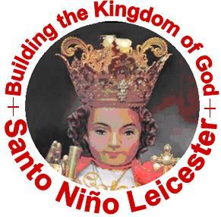 | Santo Nino Leicester  Building the Kingdom of God  info@stoninoleics.com  www.stoninoleics.com

Santo Niño Leicester Annual Report 2013

06.July.1013

Dear brothers and sisters in Christ, co-devotees to Señor Santo Niño,

“I have come as light into the world, that whoever believes in me may not remain in darkness” (Jn 12:46).

May I please be allowed to address you personally in the form of a friendly and brotherly letter in order to note some relevant things that have taken place in our past 1st year as a formally organised association; and things that we propose to do in our 2nd year and onwards. In doing this, may I also please introduce this tradition that we produce an annual report starting this year and onwards. In this report-letter, I will try my best not to be too wordy and to present it in a more pictorial through bullet points, tables, charts, etc.

Of course, everything that will be pointed out here will be purely my personal comments, suggestions and evaluations in my personal point of view; hence, an incomplete picture. The point of this report is to start a process of reflection and discussion among ourselves; hence to have a more complete picture of what we have been & have done, what we would like to improve and what we would like to do next as we progressively grow together as an association.

Introductory Summary:

Here is a brief summary of what I am about to expound and explain:
- Vision-Mission: Figuratively, we are still taking ‘baby steps’ but progressively learning to walk more self-reliantly & confidently.
- Past achievements: regular 1st Friday devotions & annual Fiesta Señor (most importantly), Constitutions and By-Laws promulgated, 1st set of officers elected, regular official and formal recorded meetings, regular 2nd Friday parish bible study, fundraising efforts on-going, voluntary saving scheme for Pilgrimage 2015 about to start, 8 more full-pledged-members added to the founding group (special mention: 6 youth).
- What we need to do next & improve? Improve 1st Friday devotion, bible study & choir practice attendance, restart pilgrim image home visitation, start Sinulog dance performance every Fiesta Señor.
- Proposed 2013-2014 Theme/Thrust: Santo Nino: “the light of our souls” and “the flame in our hearts”

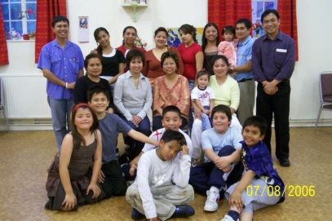
On our Vision Mission: This has been our very 1st organisational formal achievement (of course, the unfailing every 1st Friday devotion and annual Fiesta Señor celebrations since 2001 is “the” 1st and most important). We initiated this in our organisational reflection in 2006 when shared with one another in an assembly our reflections and suggestions for the direction of our group, created a provisional vision-mission statement, continued to reflect on it through the next years and finalised in 2011.

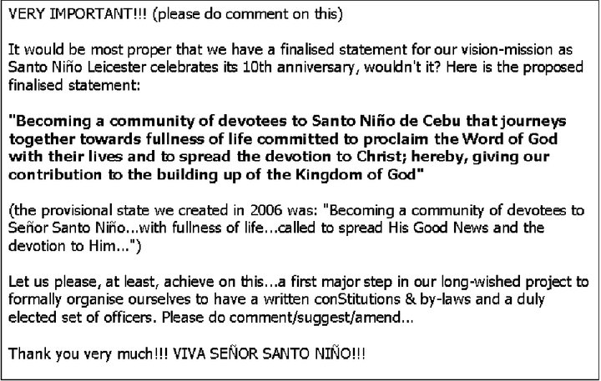
Posted via SNL FB group 09.Dec.2010. (Photo above: 2006 Organisational Reflection Assembly)

Figuratively speaking we are still taking ‘baby steps’ in achieving what we envisioned ourselves to become; or more practically speaking, we have just begun in becoming that (not yet there, but on our way there; progressive verb).
- “a community of devotees”: The devotion to Señor Santo Niño de Cebu is what brought us together. Christ brought us together! He is the reason why we exist. Why did He bring us together? Let us answer that together as we continue searching for His will and His plan. We can only try our best or contribute our part in fulfilling this divine design, but He is the ‘master-planner’ and ‘master-implementation-officer’ and we His working helping hands. We pattern our community according to our apostolic traditions and have the 1st Christian (‘prototype’) community as described in the Act of the Apostles as our point of reference of how to be a ‘church’ or in the words of the current Church leaders: a basic ecclesial community (BEC), a ‘micro-church’ within our ‘macro-Church’. We shall continue to strive, as our universal Church is doing, to live in Kyregma (Evangelisation), Leitourgia (Liturgy/Worship), Koinonia (Fellowship) and Diakonia (Service).
- “towards fullness of life”: We took this from Christ who said: “I have come so that they may have life and have it to the full” (Jn 10:10). And we cooperate with Christ in bringing our lives to meaningful, purposeful and fruitful fulfilment.
- “to proclaim the Word of God with our lives”: May our lives reflect the teachings of Christ that we continue in striving to learn and believe them in the Scriptures and in our Church, to celebrate as we frequently participate fully and actively in our Liturgy and Sacraments, and to practice to live in our daily lives wherever and whenever. We may stumble many times as we journey together in this path – ‘The Way’ – but may we have mutual help and support from one another in this our Christian vocation rooted in our baptism.
- “to spread the devotion to Christ”: We have been entrusted the task of spreading the true, sincere, authentic devotion to Christ; not just ‘limited’ to the image of the fragile infant king Jesus (Santo Niño) but to whole Christ Jesus – our God-made-man, the 2nd person of the Blessed Trinity, fully divine and fully human, the King who “will come again to judge the living the dead” (final judgment, 2nd coming), the Sacred Heart, the Divine Mercy, etc. However, before we can begin to evangelise, we first have to be evangelised; and then continue to be evangelised whilst evangelising.
- “building up the Kingdom of God”: That is the whole purpose of Christ’s life. That is the purpose of the Church. That is also the ultimate purpose of our association.

On our past achievements:
- Regular 1st Friday devotions & annual Fiesta Señor: We have never failed in this since the foundation of our devotional practice since 2001. This is our most important and most significant achievement. May we keep up the good work!
- Constitutions and By-Laws promulgated: It took us years and years (2006-2012) to come up to this, but finally we had it promulgated when 21 of us were officially and formally inducted into full-membership during our Fiesta Señor 2012 celebrations; and then affixed our signatures on 3 official copies of our Constitutions & By-Laws (a copy each for the association, the parish & the diocese). Here is a brief timeline:
- Jan 2006: we started calling ourselves as ‘Santo Niño Leicester’
- Aug 2006: created our provisional Vision-Mission statement
- Jul 2007: acquired a copy of the Confradia del Santo Niño de Cebu Constitutions & By-Laws from the current rector of the Basilica del Santo Niño de Cebu with the intention of possibly formally integrating ourselves to them and become a chapter confradia
- Jan 2011: finalised our Vision-Mission statement
- Feb-Aug 2011: drafting and virtual constitutional convention via SNL FB group. I made the working draft mostly based and practically copied from the Confradia’s and posted for comments, suggestions and editions every Friday.
- Jan 2012: 21 founding members promulgated our Constitutions & By-Laws
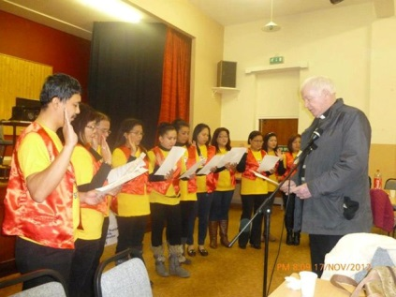
- 1st set of officers elected: Having promulgated our Constitutions & By-Laws to lead and guide us, we shortlisted for our priority-3 short-term targets (2012-2014) and priority-3 long-term targets (2012 and beyond). Finally, having both guidelines & directives, we elected from among ourselves officers to help us achieve them on 14.July.2012. They had their oath-taking on 17.Nov.2012.
- Regular official and formal recorded meetings: So far we had 2 Quarterly Assembly meetings (QAM) yet and 2 Steering Council meetings (SCM) plus 2 special SCMs. We are running behind our constitutional requirement of every 3 months or 4 in a year for the QAMs; however, let us please be patient with our ‘baby steps’. Let me please re-mention it here about some sound attitude and mentality:
- What is most important is the constancy of our monthly 1st friday devotions & annual fiesta señor; the rest (other activities & events, formalities, etc.) comes 2nd only.
- Let us not be too rigidly legalistic: 'our by-laws are made to serve for our good, and not vice versa' just like 'the Sabbath is made for man and not man for the Sabbath'. Therefore, if there is reasonable cause for a greater good: 'there are always exceptions to every rule'.
- Regular 2nd Friday parish bible study: Thanks to our Year of Faith celebrations 2012-2013 and thanks of Blessed Sacrament Church, we have achieved this target. Most noteworthy is this parish activity was suggested and initiated by us. Began in January 2013 and on-going, we hope that this will continue even after the Year of Faith celebrations.
- Fundraising efforts on-going: This has actually been on-going year after year since we named our group Santo Niño Leicester in 2006. May we keep up the good work! Our association does need the funds as our body needs food or our car needs fuel. One thing worthy of taking note is to treat our funds simple as one of our ‘tools’ to help us in our ‘work’; the more efficient & effective, the better; but we do need to ‘get/keep working”.
- Voluntary saving scheme for Pilgrimage 2015: Absolutely voluntary; however, ‘the more, the merrier’. Of course, the more co-pilgrims to Cebu Balisica’s Sinulog 2015 (January), the merrier.
- More full-pledged-members added: 8 more full-pledged-members were added to the founding group; 6 of them are from our young people. We have also appointed their Youth committee head and deputy. May we inspire, empower and support to make them being actively involved in our association, in our parish and in our diocese.

Recommendations for improvement:
- May we improve on our 1st Friday devotion, bible study & choir practice attendance. Let us always keep the spirit of voluntarism, welcoming and inclusivity.
  - Let us be reminded that when we pledged full membership in front of Christ within the Holy Mass, we first-in-foremost pledged our devotion to Him. The 1st Friday devotion is the primary reason why we exist (of course we can do a lot better than that in the practice of our Christian faith). Our ‘confederate’ (as we call them) brothers and sisters in Cebu (and other places in the Philippines & worldwide) are actually doing the devotion every Friday; we only do communally once a month. However, let our virtual perpetual devotion via SNL FB page (https://www.facebook.com/pages/Santo-Ni%C3%B1o-Leicester/133184363449747) help us to individually fulfil this perpetual devotional practice. Let us, however, not judge one another about this; it is primarily always personal (between the individual and Christ) before it is communal.
  - Christ is the Bread of Life. Most people immediately think of the Eucharistic species. However, that is ‘only’ (not to debase at all) the ‘sacramental’ Bread of Life; of course it is the Real Presence of Christ – the whole Christ in the form of bread and wine. Moreover, the ‘other’ or ‘real’ Bread of Life is the Word of God that nourishes our soul and our life. We both eat the Bread of Life at the table of the Word (Scriptures) and at the table of the Eucharist (Holy Communion). Just as we are careful not to spill a particle of the bread from our hands or tongues, we should also be careful not to spill a word from our ears when the Readings are read (or attention when reading it). Moreover, the (ideally 10-minute)homily during the Mass is not enough to expound and explain to make us understand the Word of God. Therefore, the only way to ‘eat & digest’ the Word of God is through bible study – communally (more enriching because of the sharing) and individually in private. May we continue feasting together on the Word of God – the Bread of Life!
  - The choir is our extended service as an association; it is not our main task. However, the better we can deliver this service to God and the worshiping people of God at the Blessed Sacrament Church (and may also be elsewhere), the more we can give glory, praise and thanksgiving to God! It was St Augustine who said that “singing is praying twice”. And the more beautiful our singing, the more we can reflect the beauty and grandeur of God. We can only improve our singing skill through constant practice. More so, .we can only improve as a better choir than we are now if we sing and practice singing together giving more colour, harmony and dynamics in our music.
- Restart the pilgrim image home visitation. This extended devotional practice that we started in 2007 has now considerably stopped; though from time to time we still have some few requests for the pilgrim image from here and there. This is also our extended service to our friends who in their ways are also devoted to Señor Santo Niño; our way of reaching out to them at their very homes and outside of the Church building and of the Sunday service. We can also utilise this as one of our ‘vocation promotion’ technique to attract more members to join our ranks. We may have ‘failed’ in this (and I personally take more responsibility on this); however, again let us be very patient and understanding with ourselves on this matter. Moreover, let us continue to encourage our friends to join us ‘virtually’ in our perpetual devotional practice via our SNL FB page where we post weekly Sunday readings reflections to accompany the perpetual novena prayers.
- To start doing some Sinulog dance performance every Fiesta Señor. Year after year, we wished to do this; but perhaps we are not ready for it yet. If we can start doing this, then we can add up this ‘celebration’ element in our annual Fiesta Señor celebrations in the spirit and style of Cebu’s Sinulog celebration. Again, patience please, we are getting there…

Proposed 2013-2014 Theme/Thrust: I wish to end this report by proposing a theme or thrust for 2013-2014. That is:
Santo Nino: “the light of our souls” and “the flame in our hearts”
As the word thrust literally mean, let it push us and lift us up spiritually and practically with some particular focus this year culminating in our January 2014 Fiesta Señor celebrations. Let it also be my proposed theme for Fiesta Señor 2014. Firstly, I borrowed the idea from the recently published encyclical of Pope Francis Lumen Fidei (Light of Faith). I wish us to read and reflect together on this document. If you have noticed, I begun this letter with a quote from Jn 12:46 which is the very 1st quote Pope Francis also used in his 1st encyclical. And then I borrowed the words “the light of our souls” and “the flame in our hearts” from the 1st verse of the song Señor Santo Niño Hymn (by S. Ezcurra) that we always sing year after year during the Fiesta Señor Mass.

Thank you very much for taking time to read this. Many apologies please for its length; I tried my best to shorten it. Now let us discuss on this together.

May Señor Santo Niño bless us all and our families and loved ones. Let us continue to journey on … “together toward fullness of life” (cf. Jn 10:10)!

VIVA PIT SEÑOR!!!

Humbly yours in Christ,

Peter Zabala
President
Santo Niño Leicester

